Fermi Acceleration (1st Order) Jones & Ellison

Chapter 3.2-3.3
With the shock-drift acceleration we arrive at an ordered deterministic acceleration process that works at quasi-perpendicular shocks. As we have indicated before there is also another not so well ordered non-deterministic process, but with certain advantages over the shock drift process. We see immediately 2 shortcomings of the shock drift process:
1) After one encounter with the shock (how many crossings during the gyrations within 1 r_{ci} of the shock doesn't matter and is counted as one shock encounter) the particle escapes. So all energization is finished in one step.
2) At the parallel shock, where we see the most persistent and strongest energetic upstream particle distributions (diffusions) nothing should happen.
This is true in principle, but the magnetic field is not as smooth as indicated in the schematic sketches. Magnetic fluctuations (Alfvén waves in essence, whose generation we will touch upon later) scatter the ions and bring them back to the shock. This initiates another cycle of the same process, or in the case of the parallel shock it allows the reflection across the shock at all.
Energy gain by reflections and consecutive shock crossings.

From this simple picture we can see that the gain of momentum in 1 cycle is
$Dp=2m(u_{\text{upstream}}−u_{\text{downstream}})$
The ultimate energy (or momentum) gain of the ions is determined by the compression ratio
$r=\frac{u_{u}}{u_{d}}$
and the probability that they are turned around again towards the shock.
Let us now assume that both far enough upstream and downstream the pitch angle scattering manages to make the ion distribution isotropic in the nest frame of the flow

shock
isotropic

isotropic <v>

V_{sw} V_{D}

Situation for diffusive shock acceleration.
Because the particles cross the shock (a discontinuity in u) they do not match the isotropic distribution when they come from the shock (transmitted or reflected). In principle, we have to compute the full distribution function here. However, let us assume:
a) shock thickness << λ
b) u << v (ion velocity of energetic ion)
Then we do not have to deal with the shock in scattering, we can just use the jump in u, and the induced anisotropy is small of order u/v. In this case we can apply the diffusion approximation and directly use the transport equation derived earlier.
$0=\frac{¶f}{¶t}\underset{(1)}{\begin{aligned}\end{aligned}}+Ñ\left[−\frac{1}{3} | | \underset{(2)}{\begin{aligned}\end{aligned}} | | \vec{u}p\frac{¶f}{¶p}−\underline{\underline{k}}Ñf | | \underset{(3)}{\begin{aligned}\end{aligned}} | | +\frac{\text{pu}}{3{\text{qB}}^{2}}(\vec{B}xÑf) | | \underset{(4)}{\begin{aligned}\end{aligned}} | \right]+\vec{u}Ñ\left[\frac{1}{3p^{2}}\frac{¶}{¶p} | | \underset{(5)}{\begin{aligned}\end{aligned}} | | \left(p^{3}f\right)\right]$ (V.3_12)
Let's look for a stationary solution, i.e. the time variation (1) = 0. For an infinite homogeneous shock (and ∇f only ||B) Therefore, the Drift Term (4) = 0. The latter can also be achieved by transformation of an arbitrary shock into the DeHofmann-Teller frame. This would make the flow ||B. Here we settle for a treatment without transformation, and move the difficulty of dealing with terms ⊥B (in (4)) into the diffusion coefficient. Because the compression at the shock (which defines the energy gain) is now partially ⊥B we have to also consider κ⊥ in κ. Yet we have eliminated the tensor. We may write:
As scalar: κ = κ || cos² θ_{Bn} + κ ⊥ sin² θ_{Bn}
(The squares come from the fact that κ ~ λ²). As a consequence the diffusion convection equation is more general and can be applied to an oblique shock. The shock-drift acceleration is included through κ ⊥ (Jokipii points this out in his treatment of the heliospheric shock for the anomalous component). The remaining terms are: (2) the convection term, (3) the diffusion term and (5) the momentum convection term due to the S_{p} flux in momentum space. Let me remind you that this is not just bow shock physics, it is applicable to all shocks.
After considering these simplifications (V.3_12) turns into:
A) $0=\frac{¶}{¶x}\left[−\frac{1}{3}up\frac{¶f}{¶p}−k\frac{¶f}{¶x}\right]+u\frac{¶}{¶x}\left[\frac{1}{3p^{2}}\frac{¶}{¶p}\left(p^{3}f\right)\right]$ (V.3_12A)
Going to the one-dimensional distribution function:
$F(p)=4{pp}^{2}f(p)→\text{Take}A)x4{pp}^{2}$
$\begin{aligned}0=\frac{¶}{¶x}\left[−\frac{1}{3}\text{up}4{pp}^{2}\frac{¶f}{¶p}−k4{pp}^{2}\frac{¶f}{¶x}\right]+u\frac{¶}{¶x}\left[\frac{4p}{3}\frac{¶}{¶p}(p^{3}f)\right] \\ \\ 0=\frac{¶}{¶x}\left[−\frac{1}{3}\text{up}\left\{\frac{¶}{¶p}F−\frac{2}{p}F\right\}−k\frac{¶F}{¶x}\right]+u\frac{¶}{¶x}\left[\frac{1}{3}\frac{¶}{¶p}(\text{pF})\right] \\ \text{add}\text{up} \\ ¯\overline{} ¯ \\ 0=−\frac{¶}{¶x}\left[\frac{1}{3}u\left\{p\frac{¶F}{¶p}−2F\right\}+k\frac{¶F}{¶x}\right]+\frac{¶}{¶x}\left[\frac{1}{3}u\left\{p\frac{¶F}{¶p}+F\right\}\right]−\frac{1}{3}\frac{¶u}{¶x}\frac{¶}{¶p}(\text{pf}) \\ ­\underline{} ­ \\ \text{cancel} \\ \\ → \frac{¶}{¶x}\left[\text{uF}(x,p)−k\frac{¶F}{¶x}\right]=\frac{1}{3}\left(\frac{¶u}{¶x}\right)\frac{¶}{¶p}(\text{pF}(x,p))\end{aligned}$
This is the diffusion-convection equation used by Jones and Ellison.
Now let's start from:
$\frac{¶}{¶x}\left[\text{uF}(x,p)−k\frac{¶F(x,p)}{¶x}\right]=\frac{1}{3}\left(\frac{¶u}{¶x}\right)\frac{¶}{¶p}\left[\text{pF}(x,p)\right]$ (V.3_13)
with a one-dimensional equation (x|| shock normal)
$F(x,p)\text{dp}=4{pp}^{2}f(x,\vec{p})\text{dp}$ (V.3_14)
for an isotropic momentum distribution f(x,p).
We integrate the equation from x = -∞ → x = +∞.
noting that $F_{\text{-¥}}=F_{1}(p)F(x³0,p)=F_{2}(p)$
and $¶u/¶x=(u_{u}−u_{d})d(x)$

The above boundary conditions imply
$\begin{aligned}¶F/¶x→0\text{for}x→\text{-¥} \\ \\ ¶F/¶x=0\text{for}x³0\end{aligned}$
Thus
$\begin{aligned}u_{d}F_{2}(p)−u_{u}F_{1}(p)=\frac{1}{3}(u_{d}−u_{u})\frac{¶}{¶p}\left[\text{pF}(x,p)\right] \\ \\ −\frac{3u_{d}}{u_{u}−u_{d}}F_{2}(p)+\frac{3u_{u}}{u_{u}−u_{d}}F_{1}(p)=F_{2}(p)+p\frac{¶F_{2}(p)}{¶p}\end{aligned}$ (V.3_15)
with r = u_{u}/u_{d}
$\begin{aligned}−\frac{3}{r−1}F_{2}(p)−F_{2}(p)+\frac{3r}{r−1}F_{1}(p)=p\frac{¶F_{2}(p)}{¶p} \\ \\ p\frac{¶F_{2}(p)}{¶p}+\left(\frac{r+2}{r−1}\right)F_{2}(p)=\frac{3r}{r−1}F_{1}(p)\end{aligned}$ (V.3_16)
The general solution of this inhomogeneous Differential Equation is
$F_{2}(p)=\left(\frac{3r}{r−1}\right)p^{−\frac{r+2}{r−1}}\int_{p_{o}}^{p}{\text{dp}'p'^{\frac{r+2}{r−1}−1}}F_{1}(p')+B⋅p^{−\frac{r+2}{r−1}}$ (V.3_17)
F₁(p) is the spectrum for the upstream region. The resulting spectrum depends only on r!
The maximum energy gain is reached for the maximum compression ratio
r → 4 thus F ~ p⁻²
For smaller r the spectrum is softer.
The homogeneous term in the relation can only contribute, if particles are generated at the shock, such as for example e⁺ and e⁻ creation at a relativistic shock. The injection of low energy ions from the incoming solar wind (thermal plasma) is contained in the inhomogeneous term. F_{l}(p') is the spectrum of the injected ions.
For example we use F₁(p') = N_{o} δ(p – p_{o}), a Delta function with injection at p.
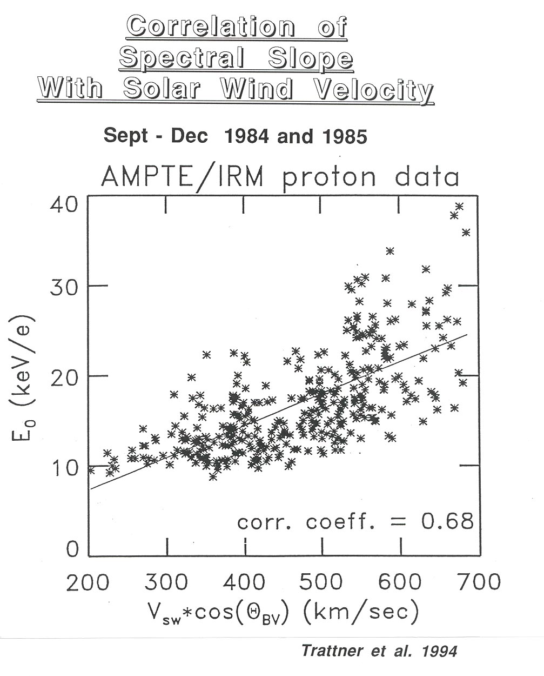
or $F_{1}(p')=N_{o}{\left(\frac{p}{p_{o}}\right)}^{−q}$
a pre-existing energetic population as used in modeling.
Note: This model cannot treat the injection out of the solar wind, because we need p_{o} >> v_{sw} for the diffusion approximation (near isotropy both upstream and downstream).
Ellison has tried to extend the validity of the approximation in his individual particle approach (Monte Carlo simulation). The results at higher energies are fine. He still needs to adjust at least one of his parameters to get the absolute flux i.e. the physics of the injection is not covered!
Finite Shock and Loss Processes
What we find is a power law spectrum, but an exponential in energy/charge is observed.
In addition, the e-folding energy E_{o} correlates well with the solar wind speed ||B, which seems qualitatively obvious from Fermi acceleration, if the process is not run to final saturation (in the power law).
What can stop the process, before it comes to its natural end? Forman and Drury pointed out that there is only a finite time available for acceleration, namely as long as a certain field line is connected to the shock. The ions are tied to the field line, because κ⊥ is small.
Comparison with Models of
Diffuse Upstream Ions
- Spectral Slopes
- Correlate with V_{sw} cosΘ_{BN}
- Scale with Energy/Charge
→ enhanced acceleration with V_{sw}
or reduced ion loss with V_{sw}?
1) Forman and Drury, 1983
Finite connection of flux tube → spectral slope
No correlation with connection time!
2) Jokipii, 1982
Importance of shock-drift term → spectral slope
No correlation with V_{sw} x B!
Correlation with V_{sw} cosΘ_{BN} is best, not with V_{sw} sinΘ_{BN}!
3) Ellison, 1981
Free escape boundary: loss is impeded by higher solar wind velocity (i.e. a stronger convection back towards the shock)
In accordance with the result, a gradual change with distance from the shock may be more realistic
4) Eichler, 1980; Lee, 1982
Loss perpendicular to the IMF: faster convection of
ions with the solar wind impedes loss
In accordance with result: perpendicular gradient?
But is hard to separate from other effects
Distance parallel to B seems to be natural frame!
- More variability at low energy end
→ High spatial and temporal resolution needed.

τ_{connection}

v_{sw}
Solar Wind
Magnetopause

Bow Shock

To reach higher energy more reflections are needed, i.e. the number of reflections n:
$n\text{proportional}\text{to}\sqrt{E}$
τ_{acceleration} longer
$F(p)\text{\sim }e^{−\frac{t_{\text{acceleration}}}{t_{\text{connection}}}}\text{\sim }e^{−\frac{α(E)\sqrt{E}}{t_{\text{connection}}}}$ (V.3_18)
However, no correlation of the E_{o} with τ_{comm} was observed.
Now the diffusion coefficient is only high in the region where the ions are (next chapter), i.e., they can leak out of the region like out of a leaky box. Ellison worked with escape ||B into the upstream region and Lee with escape ⊥B, because the BS is finite. In both cases the escape needs to be energy/charge dependent to get the result. As we see from the data, the diffusion coefficient (derived from the e-folding distance) is indeed energy/charge dependent. I.e., ions with a higher E/Q can escape more easily, which leads to a fall-off of the spectrum at high energies.

Generation of Waves by the Ions Lee, 1982; Trattner, et al.1992
Another implicit assumption is violated, namely that the energetic particles don't influence the plasma, i.e. that they are test particles. We have already seen that
ε_{Diffuse Ions} ≈ ε_{Magnetic Field}
i.e. p_{Diff} ≈ p_{B}
Thus the ions can significantly modify the magnetic field. In particular, they can create waves.

Flow ||B: Assume there is a small disturbance.
Δp_{diff}

Δp_{diff}

$\frac{B^{2}}{2m_{o}}»p_{\text{Diffuse}\text{Ions}}$
The disturbance of the flow leads to excess pressure, which increases the disturbance of the field ⊥B. Pure transverse waves → Alfvén waves
The pressure of the energetic ions leads to the so-called "fire hose instability"
with $\frac{w}{k}=V_{A}\sqrt{1−P_{||}−P\frac{\hat{}}{{B^{2}}/2m_{o}}}$ (V.3_19)
The waves are driven by the particle distribution
and their intensity I grows with the instability growth rate γ.
$\begin{aligned}g_{±}(k,x)={mαV}_{A}\sum{\frac{q_{s}}{m_{s}}\int{\text{dv}v\left(1−\frac{Ω_{\text{cs}}}{k^{2}v^{2}}\right)k_{||}\frac{¶f}{¶x}}} \\ \\ −({vmv}_{A})\frac{¶I_{±}}{¶x}=2g_{±}I_{±}\end{aligned}$ (V.3_20)
i.e. γ ~ κ||∂f/∂x the particles generate the waves!
On the other hand, the diffusion coefficient κ|| is determined by the waves:
$k_{||}=\frac{B^{2}}{4p}\frac{v^{3}}{Ω_{\text{cs}}^{2}}\frac{2}{\sum_{s}{I_{±}\left(\frac{Ω_{\text{cs}}}{v},x\right)}}$
Finally, κ|| is needed to accelerate particles at the shock, i.e. to generate energetic particles. Together with the diffusion convection equation:
$\frac{¶}{¶x}\left[uf(x,p)−k_{||}\frac{¶f}{¶x}(x,p)\right]=\frac{1}{3}\left(\frac{¶u}{¶x}\right)\frac{1}{p^{2}}\frac{¶}{¶p}\left[p^{3}f(x,p)\right]$ (V.3_21)
this leads to a set of coupled equations. They result a relation between the energy density in the particles and the energy density in the waves.
$W_{B}=6\text{.}\text{57}{\left(\frac{1−{n_{\text{sw}}}/{n_{\text{Down}\text{stream}}}}{3}\right)}^{2}\frac{V_{A}}{V_{\text{sw}}}W_{p}$ (V.3_22
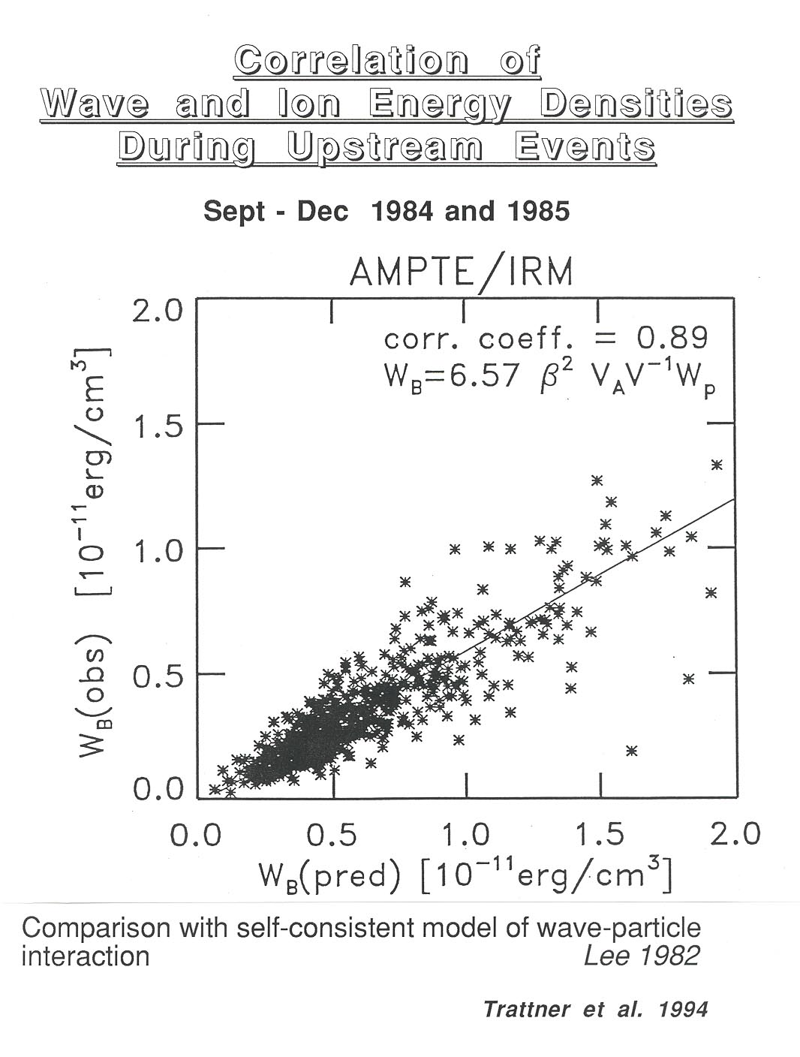
where W_{B} is the energy density of the waves and W_{p} the energy density of the particles. Observationally this is fulfilled very well.

The energy flux of the ions determines the energy flux of the waves, and the energy flux of the particles determines the energy flux of the waves.
1) What gets the process started before there are waves and particles?
2) What determines to which level this can grow?
Let us start with 2). For a strong shock, v_{A} ≈ 50 km/s and v_{sw} = 440 km/s we get as typical value for the ratio of the energy densities.
${W_{B}}/{W_{p}}»6\text{.}\text{57}{\left(\frac{1−1/r}{3}\right)}^{2}\frac{V_{A}}{V_{\text{sw}}}»0\text{.}\text{04}$
The wave energy density is
$W_{B}»\frac{{DB}^{2}}{2m_{o}}$
With W_{p}$\underset{»}{}\frac{B^{2}}{2m_{o}}$ this leads to ΔB/B > 0.1, i.e. the fluctuations can become of the same order of magnitude as the average field strength. There is a limitation to the amplitudes of Alfvén waves without compressive component ΔB/B < 1!
Thus we get a natural upper limit for our particle energy density. Several explanations were tried for the initiation of diffuse ions:
a) the beam from the perpendicular shock as seed ions
→ intensity too weak
→ composition not correct
α/p-ratio is much too low
b) escape of downstream thermal ions is the same story

Plasma Hybrid Simulations of the Bow Shock
It was not until 1989/90 that simulations of a quasi-parallel shock were carried out. In this way the microphysics at the shock itself could be treated which is hidden in Κ (diffusion-convection equation/or the mean free path and the probability to cross the shock in the test particle approach of Fermi acceleration.
This microscopic treatment uncovered a very strong wave activity at the shock with localized B⊥ and the corresponding particle reflection and acceleration.

Individual particles can gain up to 50-60 keV in one encounter by surfing the shock. In turn these particles create very strong waves which steepen into a new shock upstream.
I.e. the shock is in constant reformation.
(Burgess, 1989)
The ion acceleration is a vital part of the shock formation itself. The seed particles for wave acceleration is created naturally at the quasi-parallel shock itself. The study of these processes in detail will be an important part of the CLUSTER mission.
(Möbius, 1995)

Shock-Drift Acceleration
Term Paper Yihua Zheng
Sönnerup, 1967; Paschmann et al., 1980
V.4 Other Shocks in Interplanetary Space

After having studied shock acceleration at our front door step, the Earth's bow shock, we can apply this knowledge to other shocks. The solar wind is finally decelerated at the
Termination Shock
That is where interstellar pick-up ions get accelerated to form the anomalous component of cosmic rays. We observe mainly He, O, N, Ne at 1 AU. It has been verified recently that these ions at energies around ≈100 MeV/Q are indeed singly charged!
Application of diffusive shock acceleration including the drift acceleration at the quasiperpendicular shock gives good results.

Interesting question? Why do we only see the pick-up ions accelerated and not all the other solar wind ions?

a) To be observed at 1 AU the ions have to diffuse upstream in the solar wind:
In the form $G=\left(uf−k\frac{¶f}{¶x}\right)$
we see that an ion distribution has to build up a gradient in order to move upstream. Only if κ is large the gradient can be small and thus the remaining flux at 1 AU substantial. For ions with large rigidity indeed:
$R=\frac{p}{Q_{e}}$ κ is large
i.e. singly charged ions have an advantage.

b) Singly charged ions seem to have an advantage also in the injection into the shock acceleration.
This is a new result in corotating interaction regions
Viewgraph
These are regions where fast SW overtakes slow wind. Shocks are formed which rotate with the sun (28 days). Here again ions are accelerated. These shades are visible throughout the solar system, as far as explored. Recent observations by Gloeckler and Geiss (1994) seem to suggest that pick-up ions He⁺ and H⁺ are
Viewgraph
preferably accelerated here, as can be seen in comparison with He²⁺. Note: H⁺ is also pick-up here! Sometimes we seem to see a similar behavior at the bow shock, but the results are still puzzling, because at fluxes no He⁺ seems to be accelerated.

Interplanetary Traveling Shocks
There is yet another type of event: Occasional strong shocks that travel outward from the sun. These become particularly strong in the outer heliosphere, because the strongest events overrun all the others and scoop up everything.
Viewgraph
Upstream and downstream of these shocks intense energetic particle distributions are seen, which can again be basically modeled in the same way. Main differences:
- larger scales → higher energies
- quasi-perpendicular shocks
These events are also known as energetic storm particles (ESP) events, because they coincide with the commencement of magnetic storms at the Earth.
Viewgraph
The Earth's magnetosphere is lit by the strong shock wave. As can be seen here, the ESP event is preceded by an even more energetic particle event without simultaneous shock. These are the energetic particles directly accelerated by a flare on the sun.

References:
Burgess D. Cyclic behavior at quasi-parallel collisionless shocks, Geophys. Res. Lett., 16, 345, 1989.
Ellison D.C., Monte-Carlo simulation of charged particles upstream of the Earth's bow shock, Geophys. Res. Lett. 8, 991, 1981.
Jones F.C. and D.C. Ellison The plasma physics of shock acceleration, Space Sci. Rev. 58, 259, 1991.
Lee M.A., Coupled hydromagnetic wave excitation and ion acceleration up stream of the Earth's bow shock, J. Geophys. Res. 87, 5063, 1982.
Möbius, E., Studies with Cluster upstream and downstream of the bow shock - An experimenter's perspective, ESA-SP, 371, 127, 1995.
Paschmann G., N. Sckopke, J.R. Asbridge, S.J. Bame and J.T. Gosling. Energization of solar wind ions by reflection from the Earth's bow shock, J. Geophys. Res., 85, 4689, 1980.
Sonnerup, B. U. Ö.. Acceleration of particles reflected at a shock front, J. Geophys. Res., 74, 1301, 1969.
Trattner K. J., Möbius E., Scholer M., Klecker B., Hilchenbach M. and Lühr H., Statistical analysis of diffuse ion events upstream of the Earth's bow shock, J. Geophys. Res. 99, 13389, 1994.

